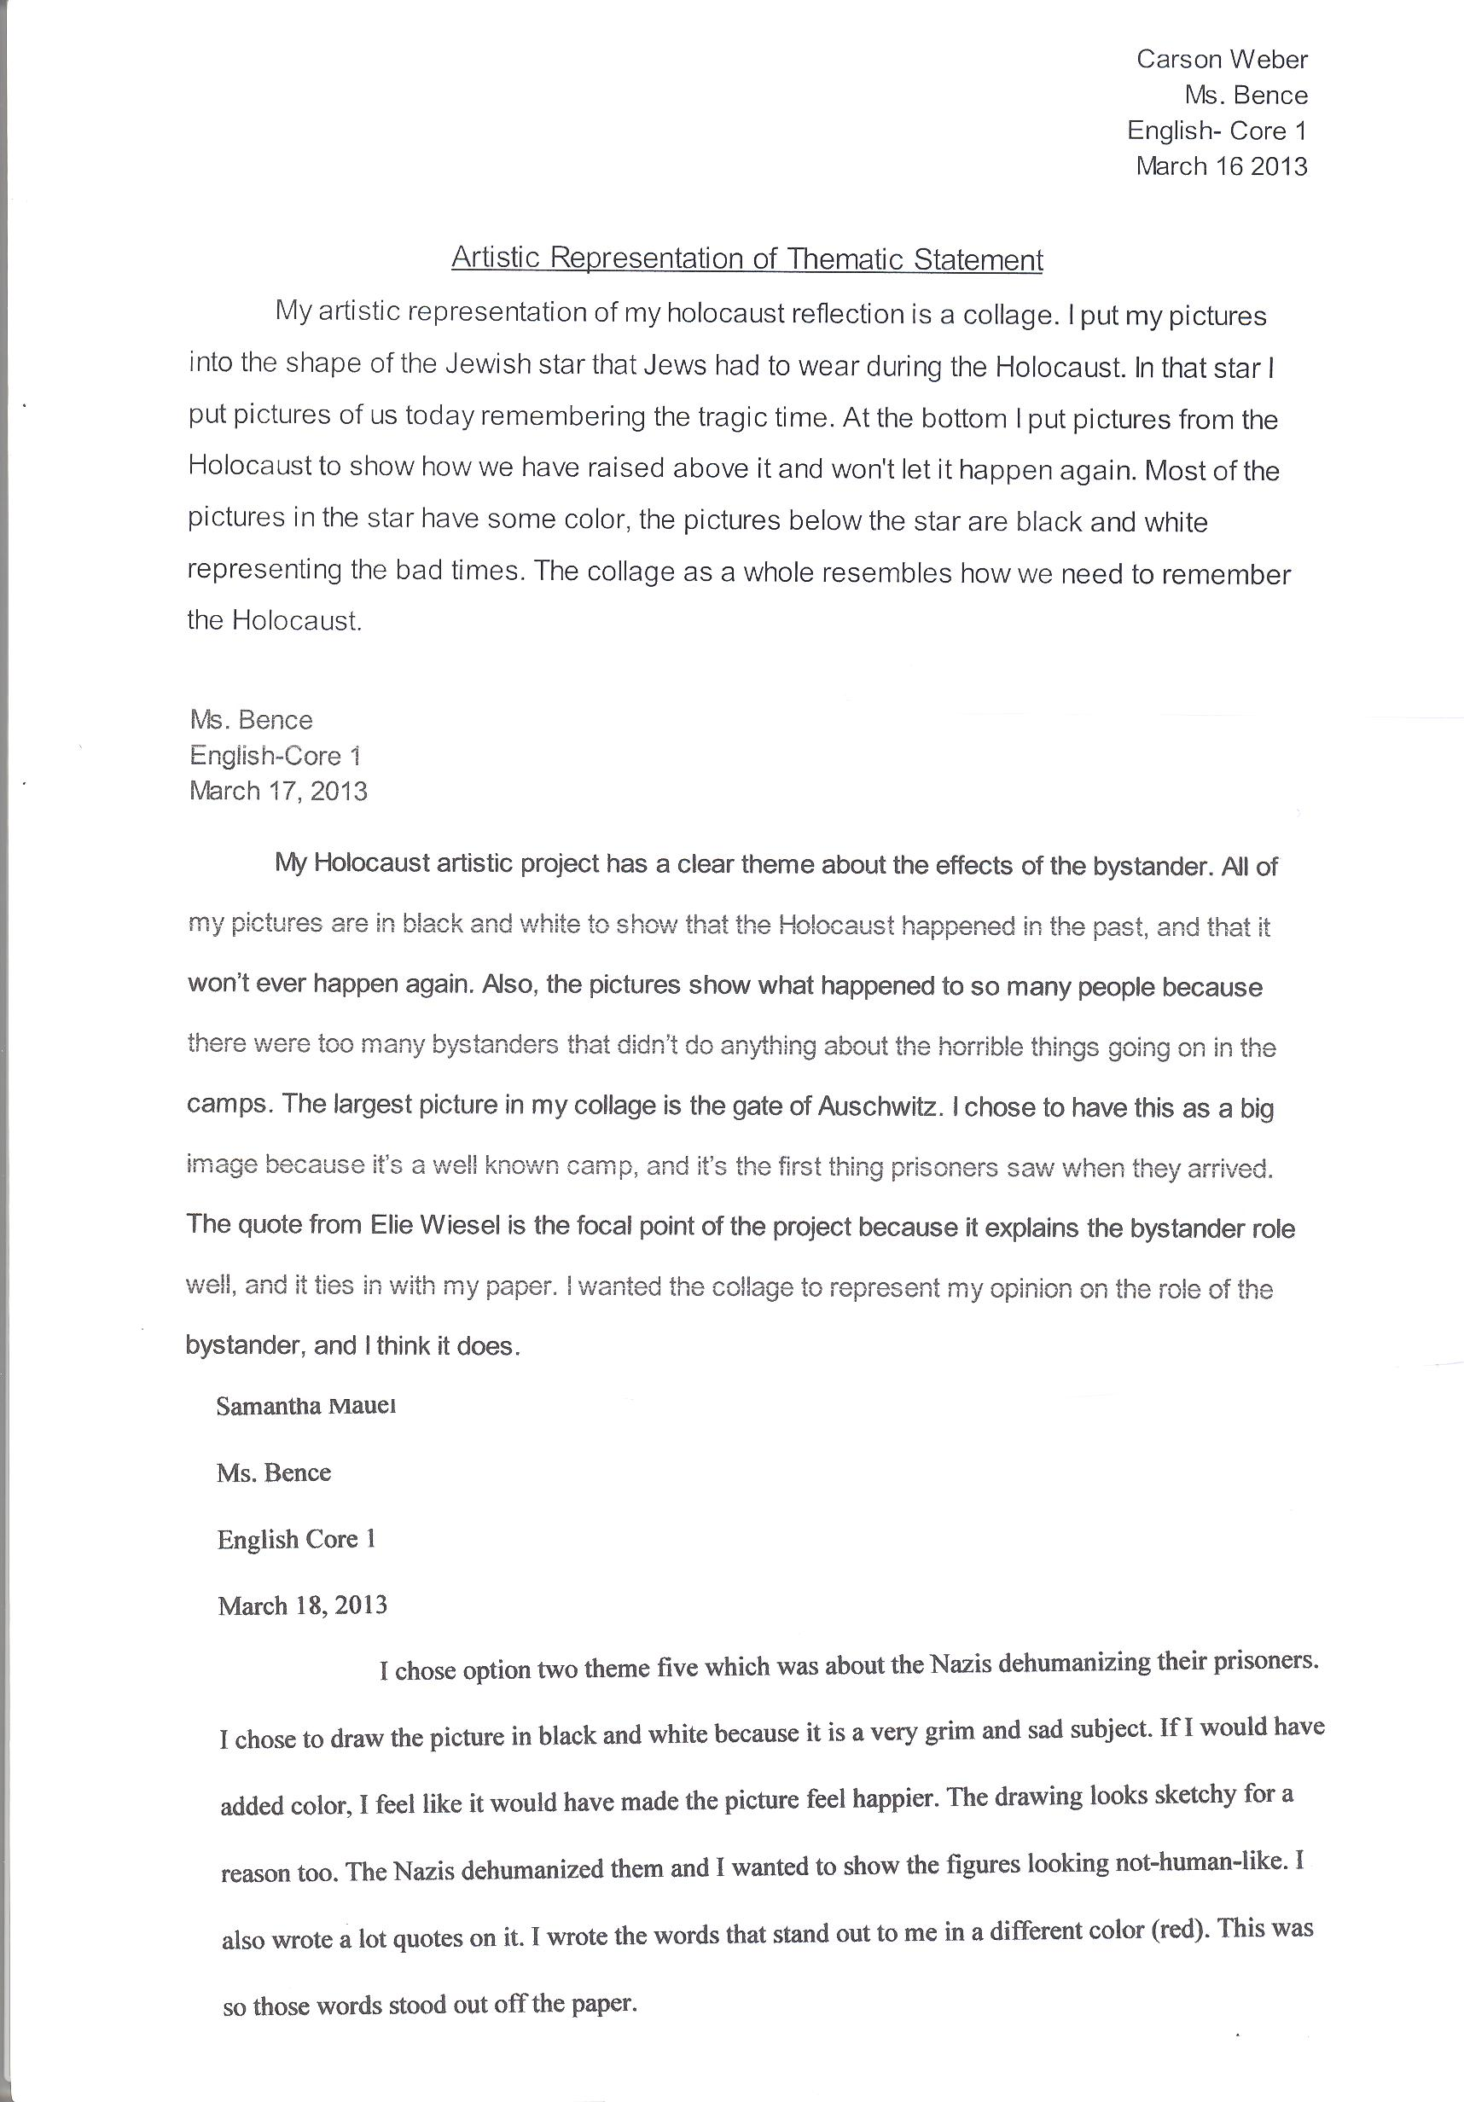

Artistic Representation Explanation Examples

Example 3

Example 2

Example 1